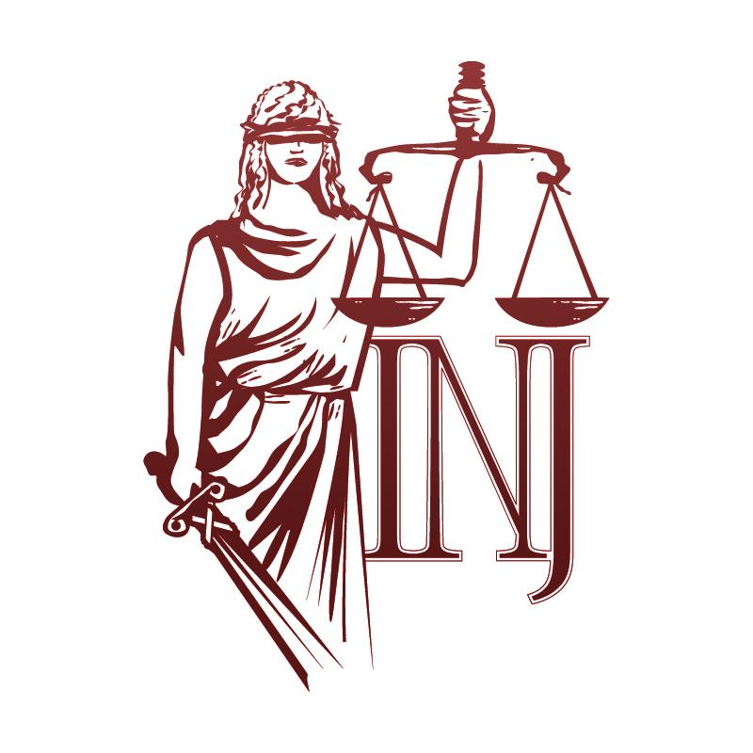 | COMITETUL COORDONATOR AL DONATORILOR  THE DONOR COORDINATION COMMITTEE  COMITÉ DIRECTEUR DES DONATEURS  SPENDER KOORDINATIONSKOMITEE

MD-2004, Chișinău, str. Serghei Lazo, 1, tel/fax: +373(22)23-27-55, E-mail: inj@inj.gov.md, web: www.inj.md

AGENDA
NIJ Donors (Partners) Coordination Committee Meeting
Institutului Naţional al Justiţiei
18 June 2015, 10:00 A.M.
1 Serghei Lazo Street
Room 4
10:00 – 10.10 | Registration.
10:10 – 10:30 | Cooperation and partnership: the NIJ activity priorities.  - Contribution of the NIJ donors during 2014;  - NIJ’s 2016 Priorities;  - Efficiency solutions for the activities organized in partnership with the donors to modernize training process .  Reporter: Diana SCOBIOALĂ, Executive Director, NIJ.
10:30 – 10:45 | Presentation of the activities organized in partnership with USAID ROLISP Programme.  Reporter: Frederick G. YEAGER, Director, USAID ROLISP.
10:45– 11:00 | Presentation of the UNDP Project „Strengthening Technical Capacities of the National Institutions for the Human Rights Protection and Promotion”.  Reporter: Alexandru COCÎRŢĂ, Project Manager, UNDP PNUD.
11:00 – 11:15 | Presentation of the activities of the Leavitte Institute Donor in accordance with the Memorandum of Understating signed with the NIJ.  Reporter: David LEAVITTE, Director, Leavitte Institute
11:15 – 11:35 | Sugestions. Proposals. Conclusions.
11:35 | Coffee break.

